Exploration 1.2: Rock Paper Scissors

### Objective

The purpose of this exploration is to introduce the formal language of inference. This includes the terms null/alternative hypothesis and p-value.

### Spiral:

How did we use Heads and Tails in our last class to simulate whether Harley (the dog) could understand verbal cues from a human?

asdfkljasd;lfjas;dlfkjasdl;kf

### Rock Paper Scissors

We want to find out if people playing Rock-Paper-Scissors tend to win their games with each “weapon” with equal probability. For example, do people tend to pick Rock more than Scissors? Paper more than Rock? To research this, let’s say that we asked 50 people to play three games each of the game, and record which weapon won the game.

Results: Let’s imagine that out of the 150 games, we found that Rock won 40 times, Paper won 41 times and Scissors won 69 times. Wow!

We suspect that for some reason that Scissors has some sort of advantage and tends to win more frequently than the other tools.

How can we test this?

1. Based on the description provided, state the research question.

Does scissors have an advantage, resulting in more than it’s share of winning games?

1. *Design a study and collect data.*
2. Identify the observational units of study?

One game of RPS

1. Describe the variable in the study. What are the possible outcomes? Is this variable quantitative or categorical?

Categorical data, three possible outcomes, but the event we are interested in is a binary categorical variable: {Scissors wins, Scissors loses}

1. Describe the parameter of interest (in words).

Our parameter of interest (pi) is the long-run proportion of times that scissors wins in RPS.

1. What are the two possibilities that could happen here relative to the winning weapon?

No advantage for S S does seem to win more frequently

1. Express the above possibilities using the parameter of interest in the form of a NULL and ALTERNATIVE hypothesis.

NULL (H0): pi = 1/3 (no advantage) ALTERNATIVE (Ha): pi > 1/3

*3. Explore the data*

1. The researchers found that out of 150 games, scissors wins 69 time. Calculate the value of the relevant statistic (let’s call this p-hat).

(phat = 69/150)

## [1] 0.46

Our observed value of p-hat is 0.46, this means that 46% of our games observed were won by scissors.

1. Now express the null and alternative hypothesis statements using $π$, the long-run proportion of a subject choosing tap water as their favorite.

H0: $π$ = 1/3  
Ha: $π$ > 1/3

*4. Draw inferences.*

1. Is the sample proportion (p-hat) grteater than the probability specified in the null hypothesis?

Yes, 46% is greater than 33%.

1. Is it possible that this proportion could turn out to be this large even if the null hypothesis was true (e.g. even if scissors has not advantage)?

Yes, this is possible. We want to see how likely this would be.

pi <- 1/3 # probability of success for each toss  
n <- 150 # Number of times we toss the penny (sample size)  
trials <- 1000 # Number of trials (number of samples)  
  
observed <- 69 # Observed number of heads   
  
phat = observed / n # p-hat - the observed proportion of heads  
  
data.sim <- do(trials) * rflip(n, prob = pi )  
  
histogram(~prop, data = data.sim,   
 v = phat,   
 width = 0.025,  
 xlab = "Proportion",   
 main = "Null hypothesis distribution",  
 groups = prop >= phat)

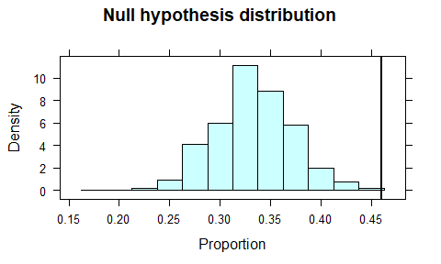

if(observed > pi * n) {  
 pvalue <- sum(data.sim$prop >= phat) / trials  
} else {  
 pvalue <- sum(data.sim$prop <= phat) / trials  
}  
  
paste("One-sided p-value is", pvalue)

## [1] "One-sided p-value is 0"

paste("Two-sided p-value is", 2 * pvalue)

## [1] "Two-sided p-value is 0"

1. What is the approximate value of the p-value? Is this small enough to provide evidence against the null hypothesis? If so, how strong is this evidence? Explain.

The approximate value of the p-value is 0.002. This is very small, so it provides strong evidence against the null hypothesis. Although it is possible that scissors does not have an advantage, our data supports that it does have an advantage.

*5. Formulate conclusion.*

1. Do you consider the observed sample result to be statistically significant?

Typically, we consider very small p-values (less than 0.05) to be statistically significant.